Club – Social Media Guidelines

Whilst often interchangeable, a social policy and social media guidelines are not quite the same thing. This document will outline the guidelines and protocol for social media production whilst keeping within the Esports Wales Club guidelines.

This booklet includes: all Esports Wales’ social profiles, guidelines for our brand voice, how to format posts and how to request social media content.

Please use the outline to go to specific sections depending on your requirements.

Club Social Profiles

Member Clubs - https://esportswales.org/clubs/member-clubs/

Brand Voice

Voice

Clean and playful humour.

Responses should always be upbeat, optimistic and positive. Avoid being sarcastic or mocking publics, followers or other brands. Avoid Welsh Banter.

Imagery

Use appropriate images and GIFs where appropriate. If possible graphics should be made by the graphics designers and approved by the social team. Disclaimer: Graphics will not be posted via social media if not approved by the social team. Everything needs to be high quality and cleanly executed, if not, it does not represent and shall not be posted.

Grammar and Terminology

Don’t write as if you were sending a message to your grandmother, but try to remember all those grammatical rules your grandmother taught you. So try to avoid slang, incorrect capitalization and spelling mistakes. Readability is number 1.

Hashtags should be used correctly too, with every new word within a hashtag having a capitalised letter - this ensures anyone using a voice to speech device will be able to have the hashtag read to them correctly, therefore, “#LetsGoEsportsWales” is correct, and “#letsgoesportswales” is wrong.

Post Formatting

Here in Wales we run a specific format when posting social media and that varies via social media platform, this section shall explain each format with visual examples of each.

X/ Twitter

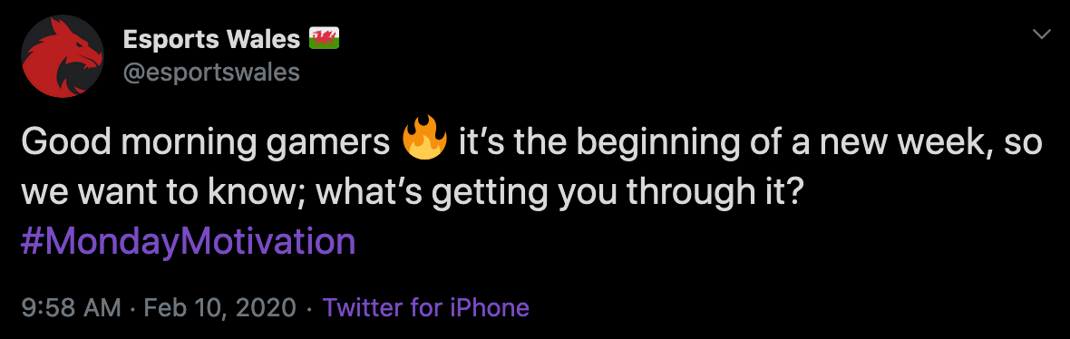
Posts should be short, snappy and to the point (see below).

Longer tweets should be formatted into mini paragraphs. Longer chunks of text will be less likely to be read (see below).

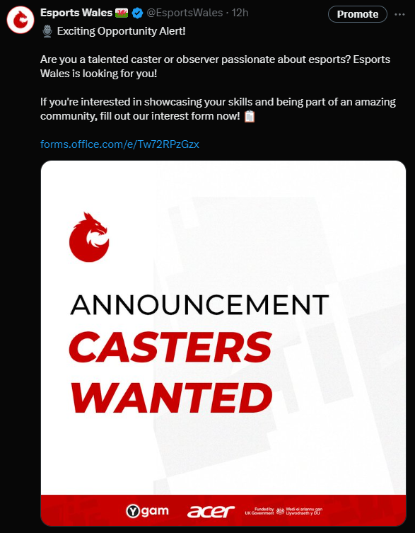

Graphics should be used when applicable and guidelines (see all attached tweets).

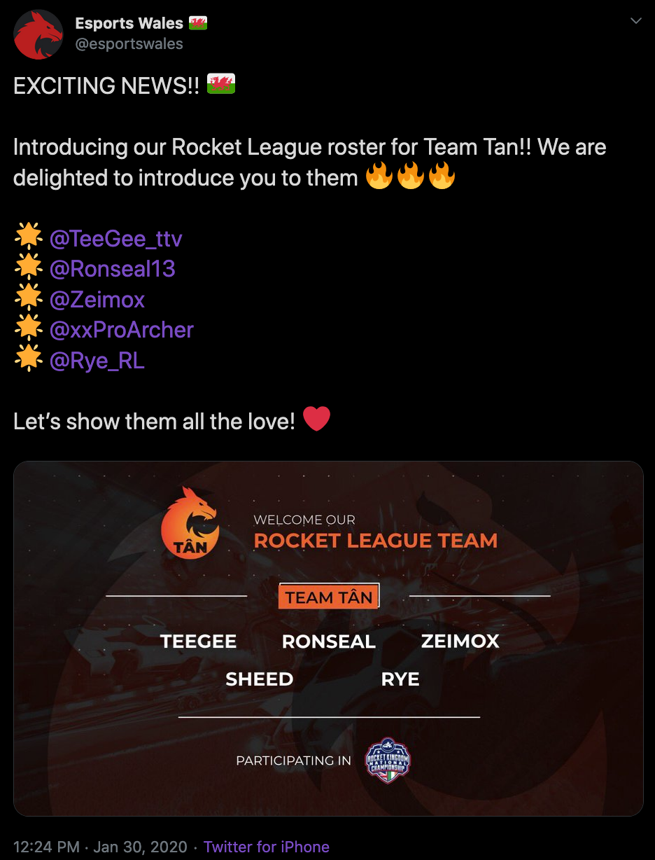

For information announcements use emojis to bullet point starts of lines.

Tag users and brands when applicable (this also includes brand specific hashtags). This draws more attention to a tweet and can increase engagement tenfold.

Retweet content posted by esports organisations in Wales. We aren’t just here to promote ourselves, we are here to grow esports as an industry in Wales and that includes schools, colleges, universities and other organisations to keep an eye on, on social media.

Facebook

Same rules apply for Facebook as with Instagram, however, Facebook can also include mass photo albums of events, staff can be more appropriately tagged and more video content can be utilised.

Facebook doesn’t need as much content posted to it as Twitter or Instagram, therefore your best posts of the day/week/month should be featured over on the Facebook account.

Instagram

ONLY post high quality imagery on Instagram

Any duplicated imagery, stock imagery should not be used.

Follow branding guidelines when adding Esports Wales’ logo to any images before posting, those guidelines can be found here.

LinkedIn

Same rules apply with LinkedIn as they do with Facebook.

Any links MUST be posted first on LinkedIn before the message.

Imagery is paramount for LinkedIn.

